RIYA MALHOTRA

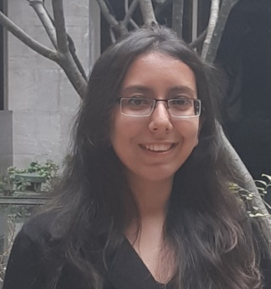
CONTACT
Address : Jaypee Wish Town,
Sector – 134, Noida – 201304.
Mobile : 9711253320
Email ID : riyamalhotra2011@gmail.com

EDUCATIONAL QUALIFICATIONS

- B.Ed. from Amity University (Noida) - 2021

- Bachelor of Arts : English Hons. from Delhi University in 2019 with Second Division (Delhi College of Arts and Commerce, New Delhi).

NSS Tanzeal : Under this project, taught underprivileged children after college hours. It was an initiative taken by the students of the college to help and motivate children coming from underprivileged background. It was a new experience for me which motivated me to pursue a career in the field of education.

- Schooling from K.R. Mangalam World School, Greater Kailash Part II, New Delhi.
Passed Senior School Certificate Examination (Class XII) in 2016 with 94.5% marks.
Subjects : English, Economics, Psychology, History, Sociology and French.
Received Scholar Badges from Class VI till Class XI.

- French Language : Cleared A1 and A2 (DELF) from Alliance Francaise De Delhi. Preparing for B1 and B2. Can teach French Language also to students from Class V to Class VIII.

INTERNSHIP
English Teacher : Internship with Army Public School, Delhi Cantt., New Delhi from August 2020 to October 2020.
- Taught English to students of Class VIII through Online mode.
- Used Power Point Presentation, Animated Videos and Quizzes to make teaching more interesting.
- Conducted Invigilation duties for various classes.
- Was also a part of the Yoga Club.
- Coordination with the senior subject teacher for the time table.

STRENGTH
Patience with the students, Good Listener, Always ready to help students whenever they are in need, Good team Player, Quick Learner, Always try to bring new methods of teaching to make it more interesting for the students.

